Question : 1
Load the 'tips' dataset from Seaborn and create a pairplot to quickly visualize relationships between all numeric variables :

import seaborn as sns
import matplotlib.pyplot as plt
tips = sns.load_dataset("tips")
sns.pairplot(tips)
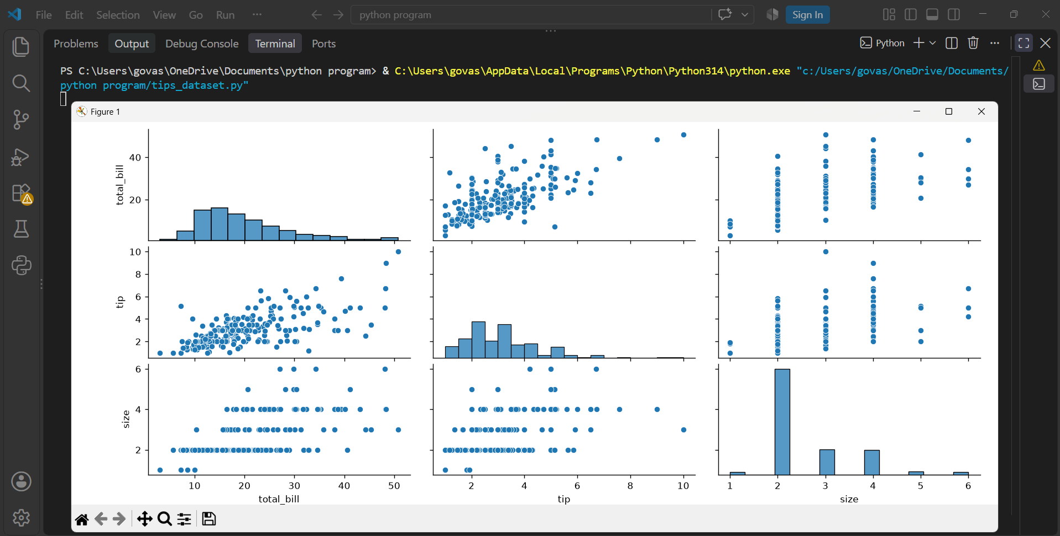
plt.show()

Question : 2
Using the 'flights' dataset from Seaborn, generate a heatmap showing the correlation between months and years based on the number of passengers.<br><br><em><strong>Hint:</strong> Use pivot_table to reshape the data before plotting the heatmap : </em>
import seaborn as sns
import matplotlib.pyplot as plt
flights =sns.load_dataset("flights")
pivot_data =flights.pivot_table(
index="month",columns="year", values="passengers")
sns.heatmap(pivot_data, annot=True, fmt=".0f", cmap="YlGnBu")
plt.title("Flights Passenger Heatmap")
plt.xlabel("Year")
plt.ylabel("Month")
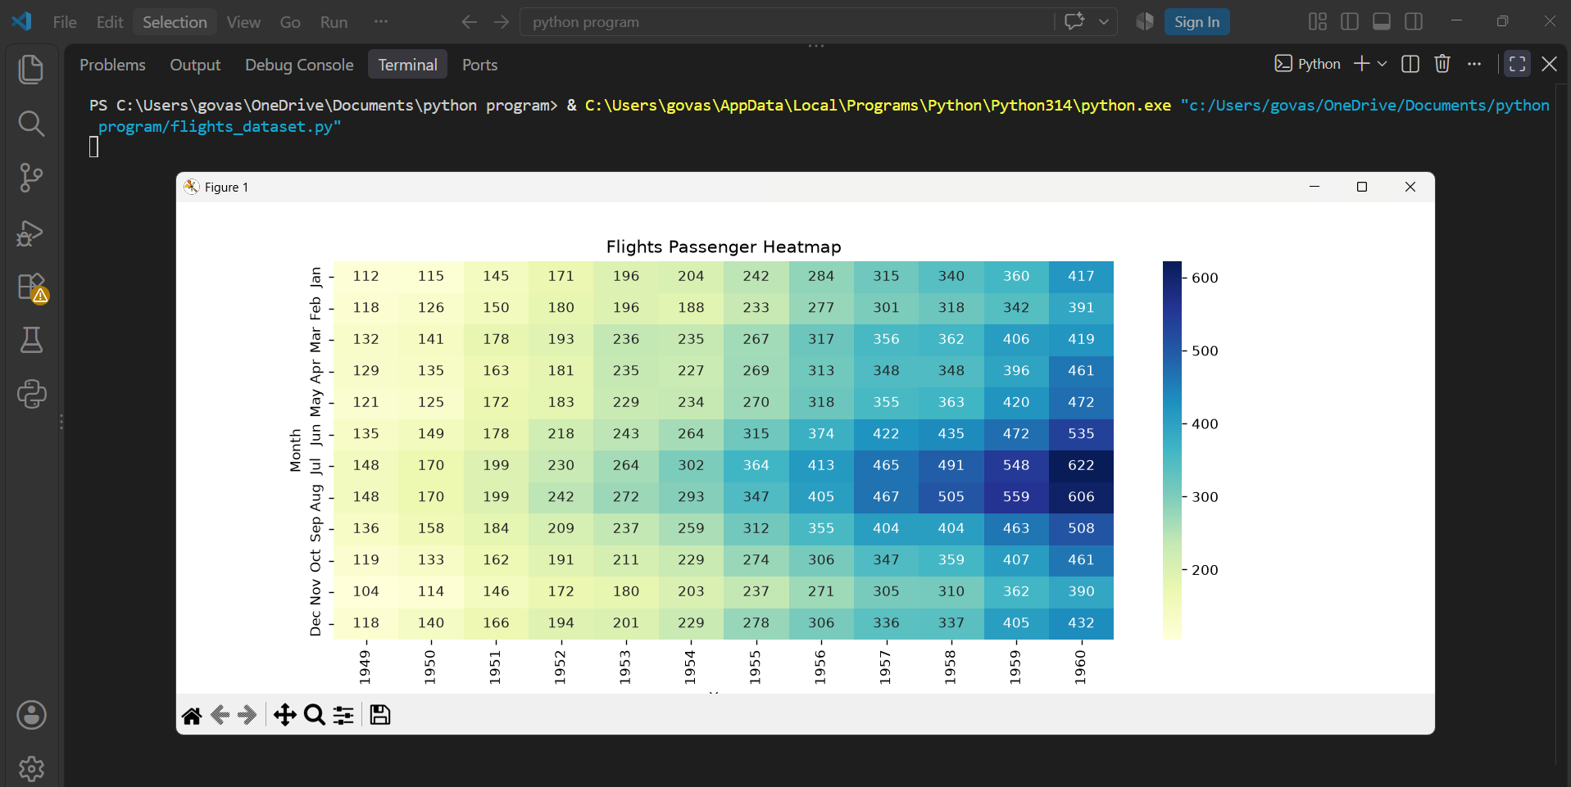
plt.show()
Question : 3
Create a relplot using the 'fmri' dataset from Seaborn to visualize how the signal changes over time for different event types :

import seaborn as sns
import matplotlib.pyplot as plt
fmri =sns.load_dataset("fmri")
sns.relplot(
data=fmri,
x="timepoint", y="signal", hue="event", kind="line")
plt.show()
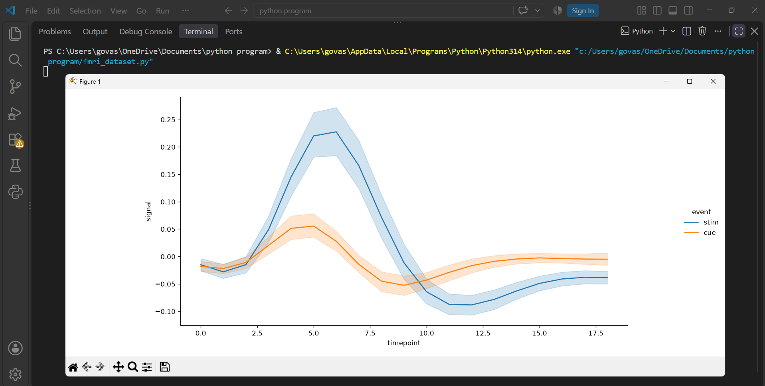
Question : 4
Pick any categorical column from the 'titanic' dataset (like 'class' or 'sex') and use catplot to display the survival rate for each group with confidence intervals:

import seaborn as sns
import matplotlib.pyplot as plt
titanic =sns.load_dataset("titanic")

sns.catplot(data=titanic,x="class",y="survived",kind="bar",errorbar="ci")
plt.title("Survival Rate by Passenger Class")
plt.xlabel("Passenger Class")
plt.ylabel("Survival Rate")
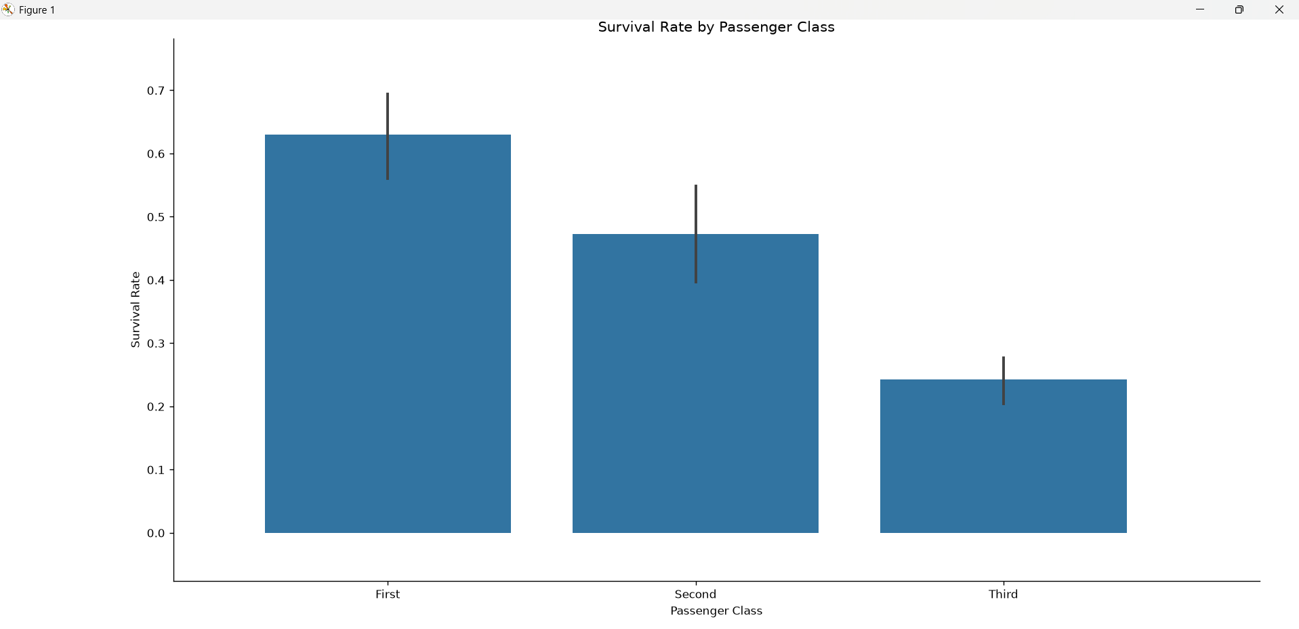
plt.show()
Question : 5
Use jointplot on the 'penguins' dataset to visualize the relationship between bill_length_mm and flipper_length_mm, and fit a regression line on the scatter plot.<br><br><em><strong>Hint:</strong> Set kind='reg' in jointplot for regression line : </em>

import seaborn as sns
import matplotlib.pyplot as plt
penguins =sns.load_dataset("penguins")
sns.jointplot(
data=penguins, x="bill_length_mm", y="flipper_length_mm", kind="reg" )
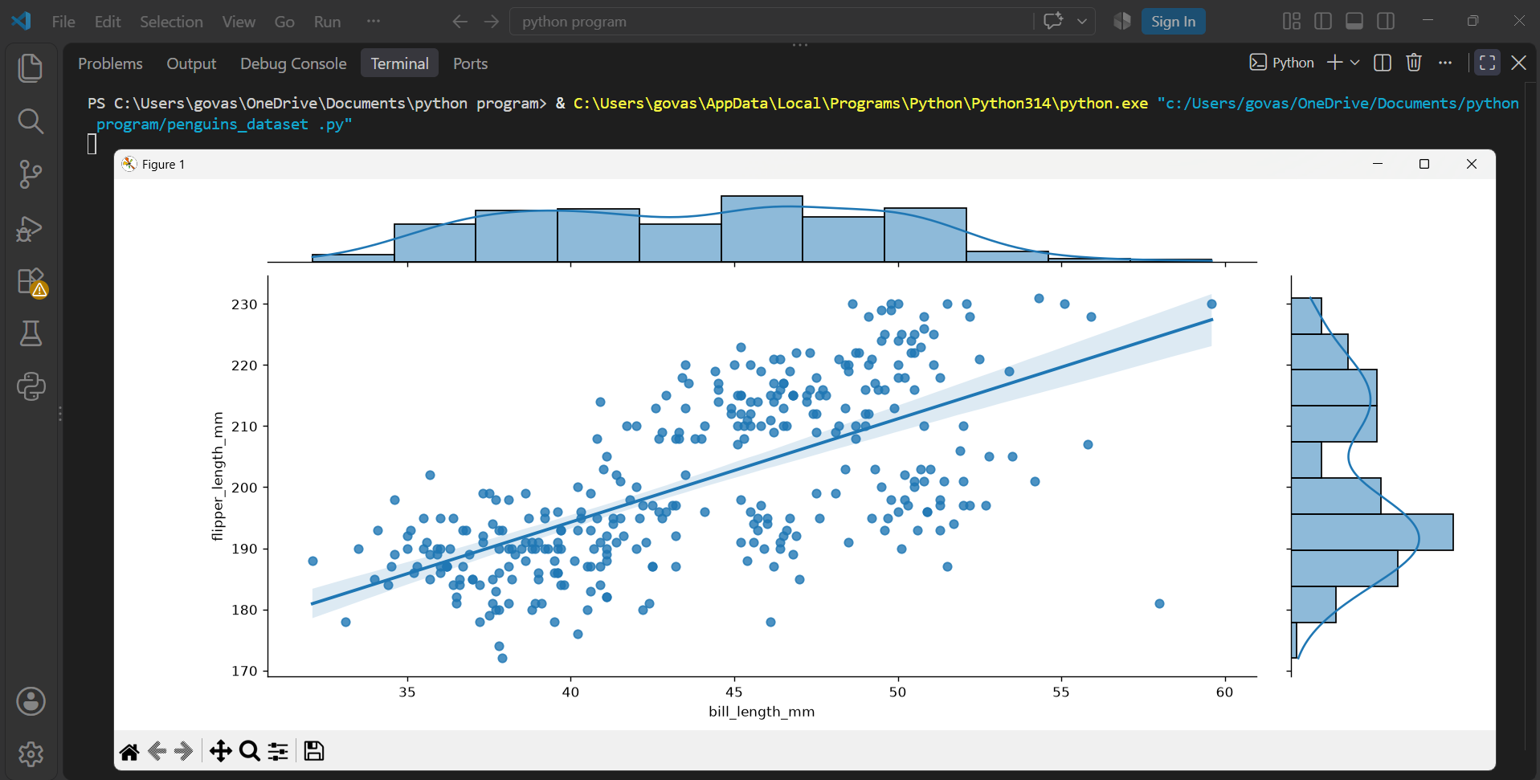
plt.show()

